

EPOCA SOCIAL MEDIA TEAM

Social Media Analysis

Using TikTok

*User Guide*

**Pulling Data from TikTok API**

1. Log into your preferred browser. **A picture containing logo

   Description automatically generated**

1. Navigate to RapidApi.com/hub

*Here you will be directed to a*

*homepage where you can sign up.*

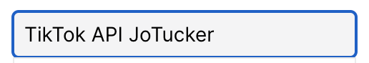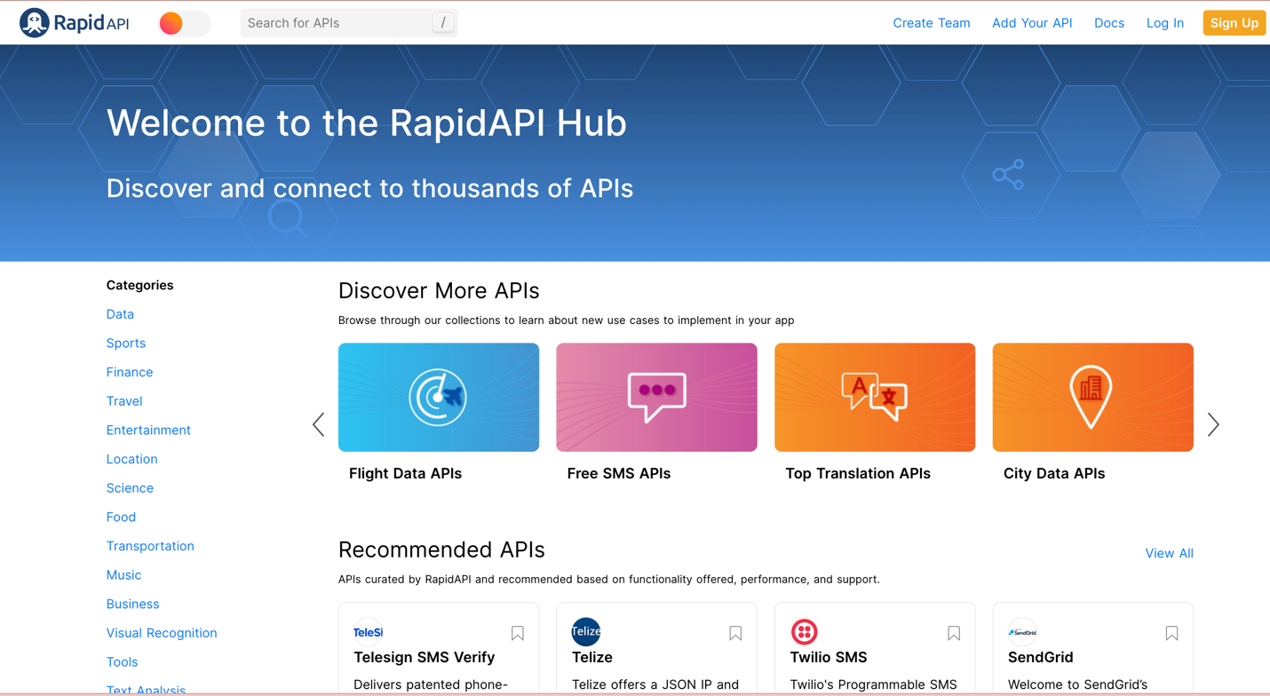

*API Name Author*

4. Search “TikTok API JoTucker”.

1. Navigate to the top left corner of the webpage to the search engine.

The result page should resemble the following.

5. Double click to enter the API’s Playground.

6. Navigate to the pricing subheading.

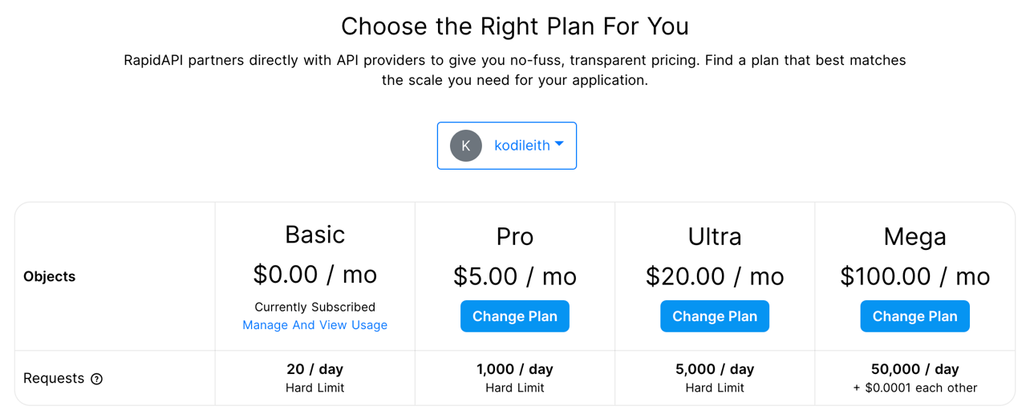



TikTok API offers different price tiers. Your chosen tier determines how many requests or pulls of data you can do in one day. {More on this later}